17. Split DataFrame by School Code and Find Mean, Minimum and Maximum Age
Aim
To write a Pandas program to split the given DataFrame based on school code and calculate the mean, minimum, and maximum age for each school.
Algorithm
- Import the Pandas library.
- Create the DataFrame containing student details.
- Group the DataFrame using the school_code column.
- Select the age column.
- Calculate the mean, minimum, and maximum age for each group.
- Display the result.
Code:
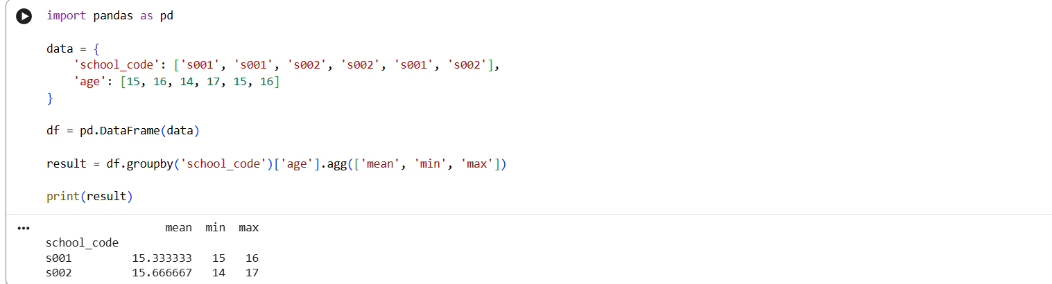

Result:
Thus, the DataFrame was successfully split by school code and the mean, minimum, and maximum age were calculated.

18. Split DataFrame into Groups Based on School Code and Class
Aim
To write a Pandas program to split the given DataFrame into groups based on school code and class.
Algorithm
- Import the Pandas library.
- Create the DataFrame containing school code, class, and student details.
- Group the DataFrame using school_code and class.
- Display each group.
- Observe the grouped records.
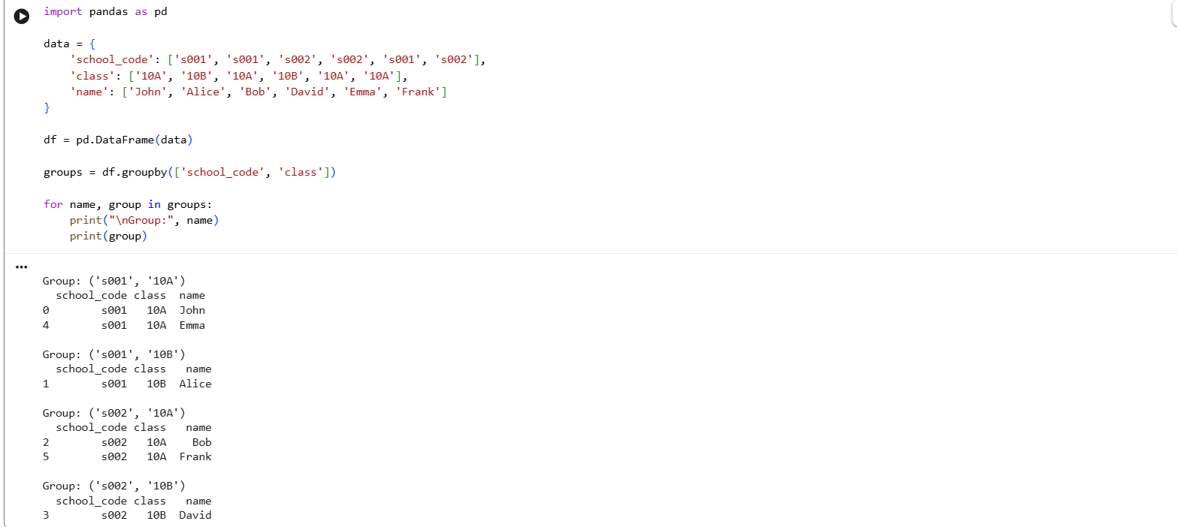
Thus, the DataFrame was successfully split into groups based on school code and class.

19. Display Dimensions/Shape and Column Names of World Alcohol Consumption Dataset
Aim
To write a Pandas program to display the dimensions or shape of the World Alcohol Consumption dataset and extract its column names.
Algorithm
- Import the Pandas library.
- Load the World Alcohol Consumption dataset.
- Use the shape attribute to find the number of rows and columns.
- Use the columns attribute to extract the column names.
- Display the results.
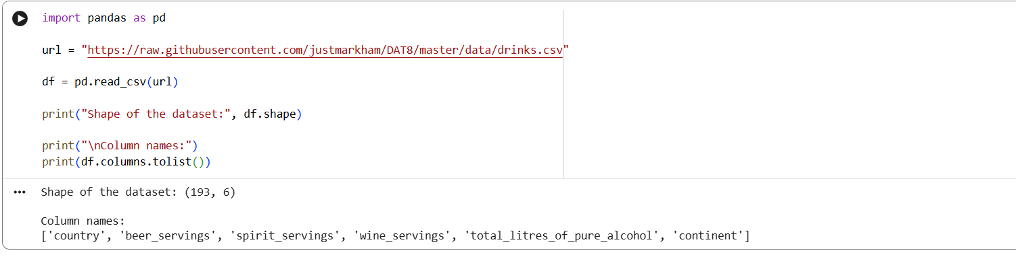
Result:
Thus, the dimensions and column names of the World Alcohol Consumption dataset were successfully displayed.
20. Find the Index of a Given Substring in a DataFrame Column
Aim
To write a Pandas program to find the index of a given substring in a DataFrame column.
Algorithm
- Import the Pandas library.
- Create a DataFrame containing string values.
- Specify the substring to be searched.
- Use the Pandas str.find() function to find the position of the substring.
- Display the index/position of the substring.
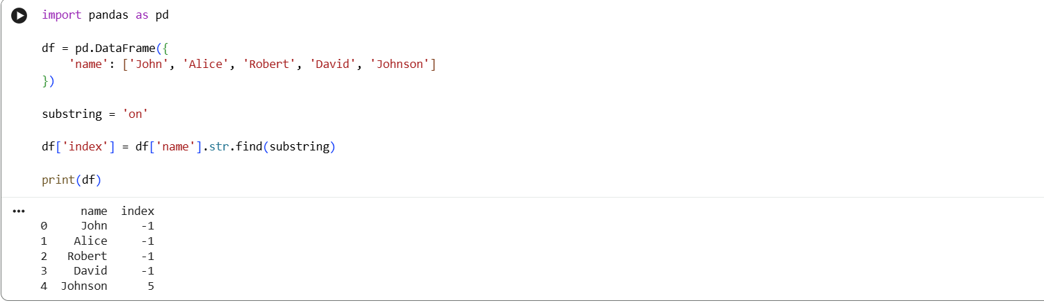
Result:
Here, -1 indicates that the substring was not found.
Thus, the index/position of the given substring in the DataFrame column was successfully found using Pandas.
21. Swap Cases of a Specified Character Column
Aim
To write a Pandas program to swap the cases of a specified character column in a given DataFrame.
Algorithm
- Import the Pandas library.
- Create a DataFrame containing character/string values.
- Select the required column.
- Use the str.swapcase() function to change uppercase characters to lowercase and lowercase characters to uppercase.
- Display the modified DataFrame.
Google Colab Code
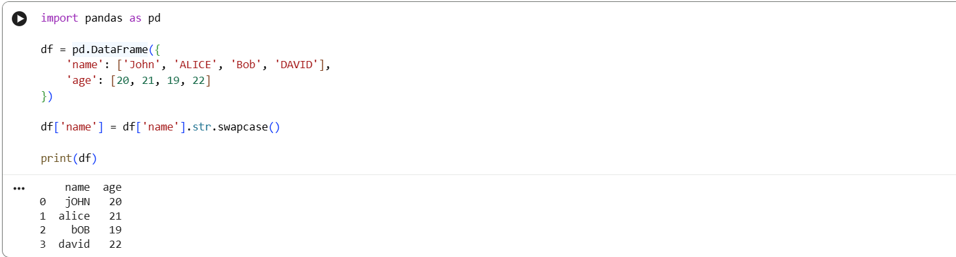
Result
Thus, the cases of the specified character column were successfully swapped.
22. Draw a Line with Suitable Labels and Title
Aim
To write a Python program to draw a line with suitable labels for the X-axis, Y-axis, and title.
Algorithm
- Import the Matplotlib library.
- Define the X-axis and Y-axis values.
- Plot the values using the plot() function.
- Give suitable labels to the X-axis and Y-axis.
- Give a suitable title to the graph.
- Display the graph.
Google Colab Code
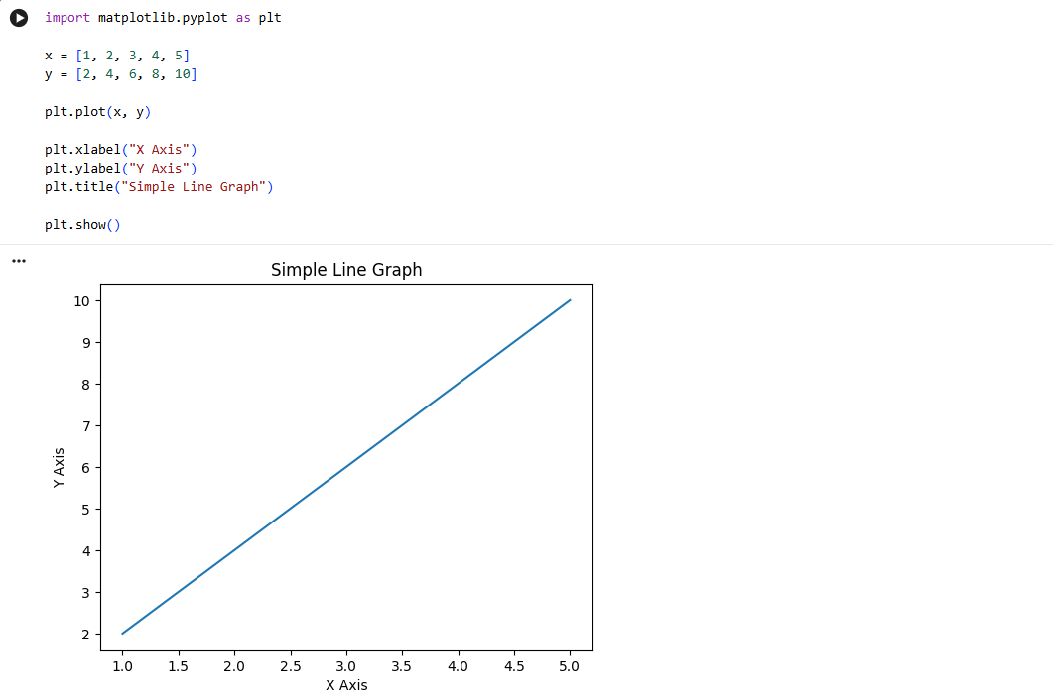
Result
A line graph is successfully displayed with X-axis label, Y-axis label, and title.
23. Draw a Line Using Axis Values from a Text File
Aim
To write a Python program to draw a line using axis values taken from a text file with suitable X-axis label, Y-axis label, and title.
Algorithm
- Create a text file containing X and Y values.
- Import Matplotlib.
- Read the values from the text file.
- Separate the X-axis and Y-axis values.
- Plot the values using plot().
- Add X-axis label, Y-axis label, and title.
- Display the graph.

Google Colab Code
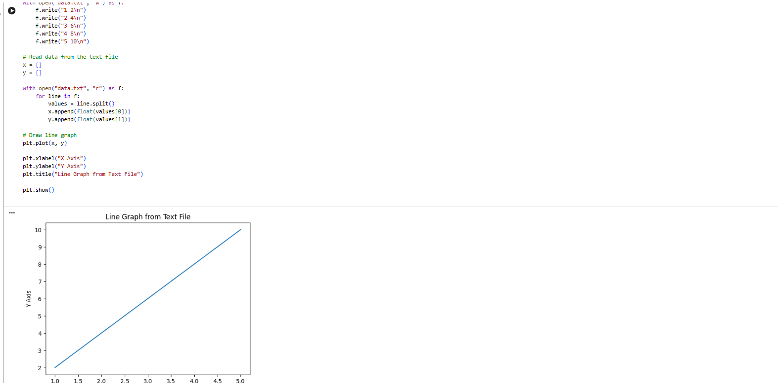
Result
A line graph was successfully plotted using the X-axis and Y-axis values obtained from the text file.
24. Draw Line Charts of Financial Data
Aim
To write a Python program to draw line charts of financial data.
Algorithm
- Import Pandas and Matplotlib.
- Create financial data containing date, open, close, high, and low values.
- Convert the date column into date format.
- Plot the financial values using line charts.
- Add suitable labels, title, and legend.
- Display the graph.

Google Colab Code
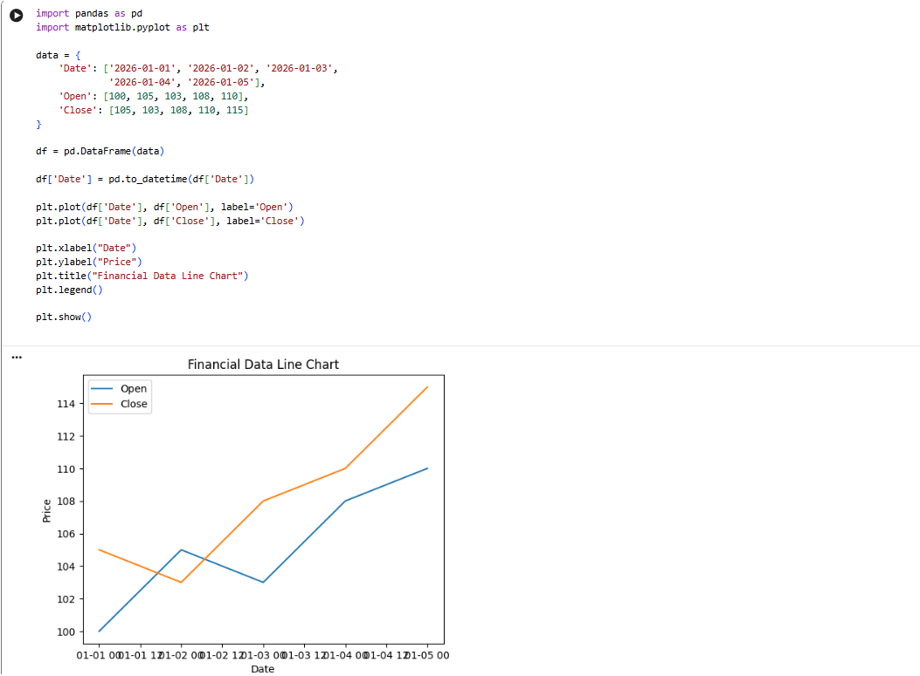
Result
A line chart representing the opening and closing prices of the financial data was successfully displayed.
25. Plot Two or More Lines with Legends, Different Widths and Colors
Aim
To write a Python program to plot two or more lines with legends, different line widths, and colors.
Algorithm
- Import Matplotlib.
- Define X-axis values.
- Define values for two or more lines.
- Plot each line with different colors and line widths.
- Add legends for each line.
- Add X-axis label, Y-axis label, and title.
- Display the graph.

Google Colab Code
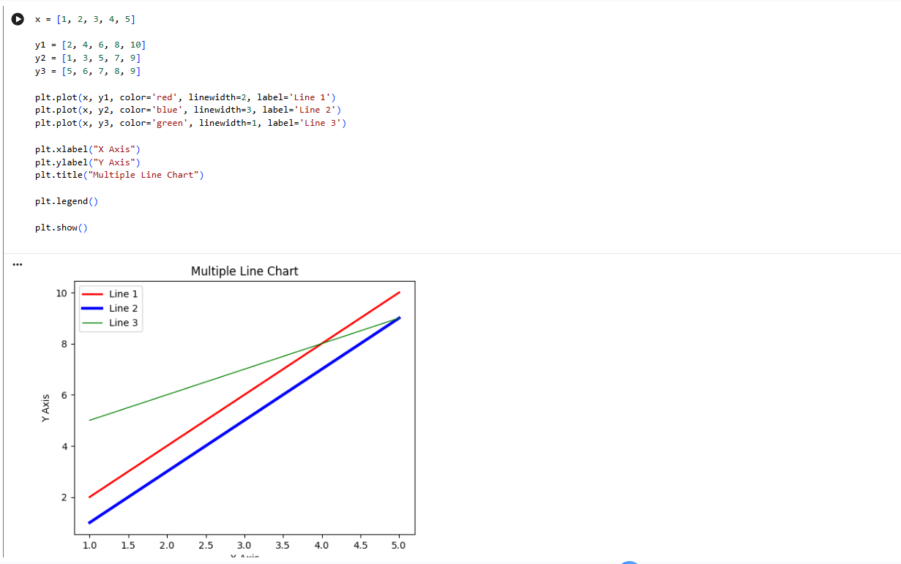
Result
A graph containing three lines with different colors, line widths, and legends was successfully plotted.
26. Create Multiple Plots
Aim
To write a Python program to create multiple plots in a single figure.
Algorithm
- Import the Matplotlib library.
- Define the X-axis and Y-axis values.
- Create multiple subplots using subplot().
- Plot different graphs in each subplot.
- Add suitable titles to each plot.
- Display the figure.

Google Colab Code
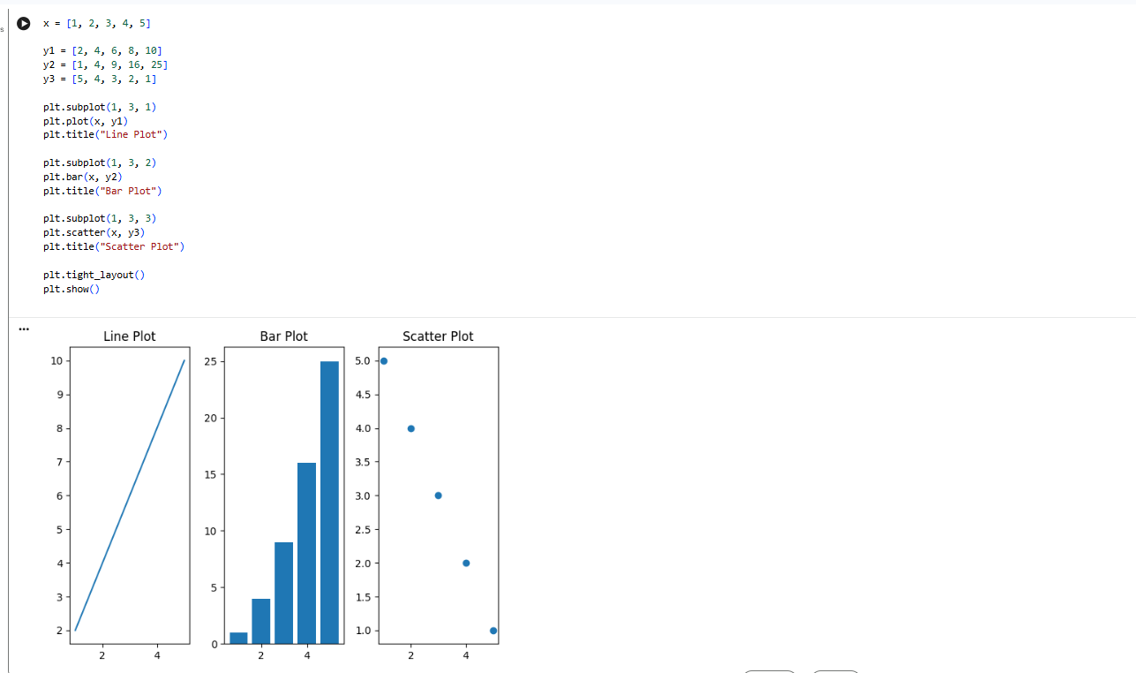
Result
Three different plots, namely line plot, bar plot, and scatter plot, were successfully created in a single figure.
27. Display a Bar Chart of the Popularity of Programming Languages
Aim
To write a Python program to display a bar chart showing the popularity of different programming languages.
Algorithm
- Import Matplotlib.
- Define programming languages and their popularity values.
- Create a bar chart using bar().
- Add X-axis and Y-axis labels.
- Add a suitable title.
- Display the chart.

Google Colab Code
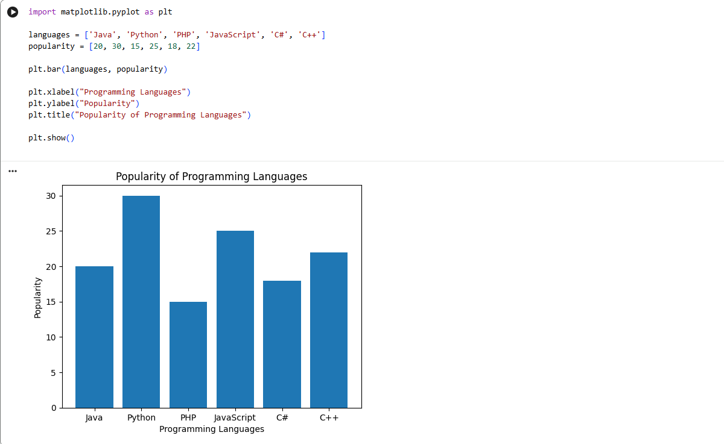
Result
A vertical bar chart showing the popularity of different programming languages was successfully displayed.

28. Display a Horizontal Bar Chart of Programming Languages
Aim
To write a Python program to display a horizontal bar chart showing the popularity of programming languages.
Algorithm
- Import Matplotlib.
- Define programming languages and their popularity values.
- Use the barh() function to create a horizontal bar chart.
- Add X-axis and Y-axis labels.
- Add a suitable title.
- Display the chart.

Google Colab Code
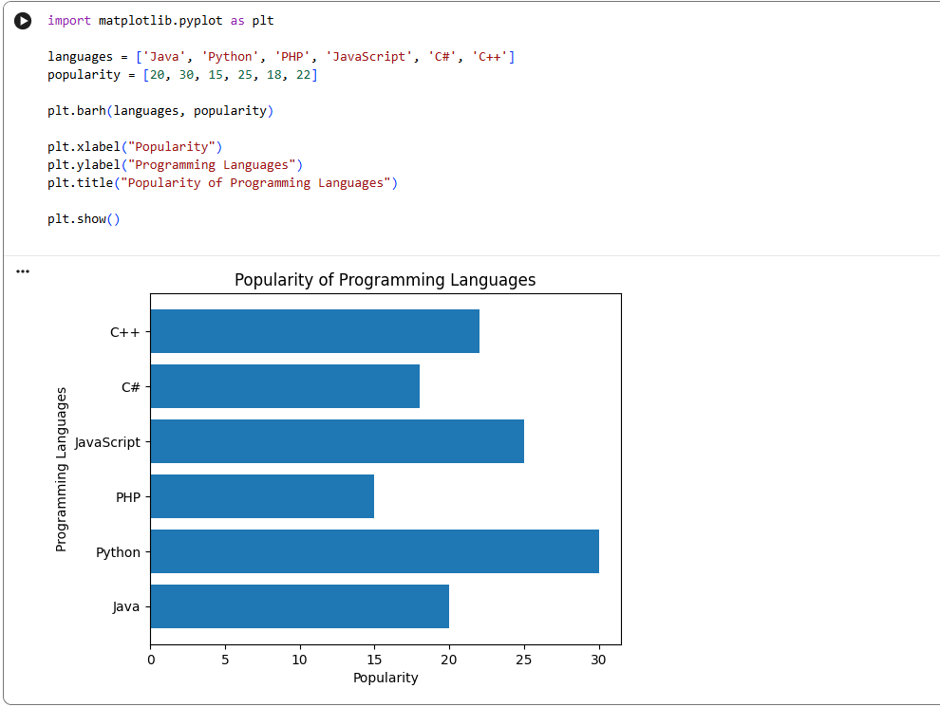
Result
A horizontal bar chart showing the popularity of different programming languages was successfully displayed.
29. Bar Chart with Different Colors for Each Bar
Aim
To write a Python program to display a bar chart of programming language popularity using different colors for each bar.
Algorithm
- Import Matplotlib.
- Define programming languages and popularity values.
- Create a list of different colors.
- Pass the colors to the bar() function.
- Add suitable labels and title.
- Display the chart.

Google Colab Code
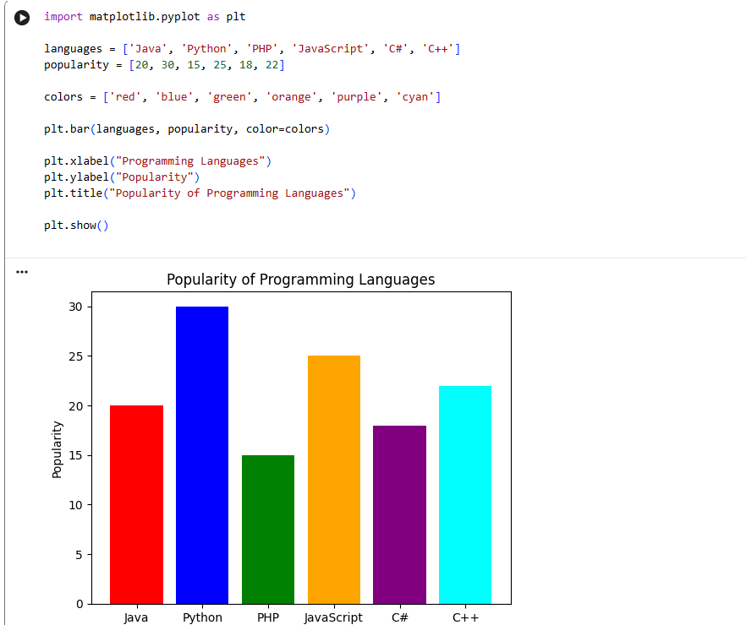
Result
A bar chart was successfully displayed with a different color for each programming language.
30. Bar Plot of Scores by Group and Gender
Aim
To write a Python program to create a bar plot of scores by group and gender using multiple X-values on the same chart.
Algorithm
- Import NumPy and Matplotlib.
- Define the groups and scores for men and women.
- Create X-axis positions using NumPy.
- Plot the men's scores with a suitable width.
- Plot the women's scores beside the men's scores.
- Add labels, title, and legend.
- Display the chart.

Google Colab Code
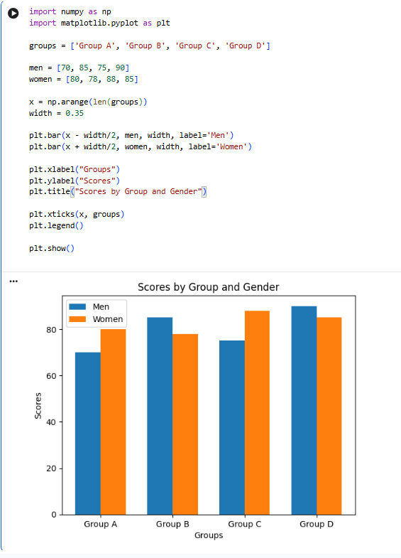
Result
A grouped bar chart was successfully created showing the scores of men and women for different groups using multiple X-values on the same chart.
31. Stacked Bar Plot with Error Bars
Aim
To write a Python program to create a stacked bar plot with error bars.
Algorithm
- Import NumPy and Matplotlib.
- Define the categories and values for two datasets.
- Define the error values.
- Create the first bar plot.
- Stack the second bar plot on top of the first.
- Add error bars using the yerr parameter.
- Add labels, title, and legend.
- Display the graph.

Google Colab Code
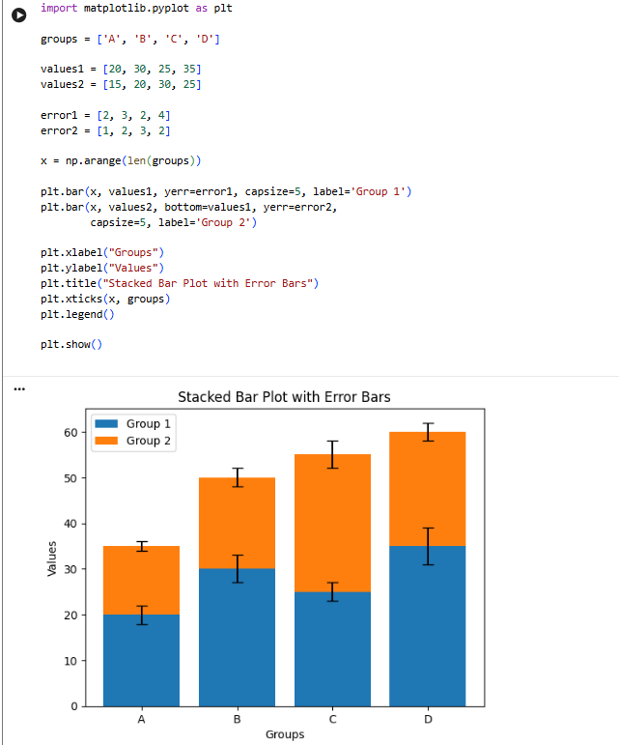
Result
A stacked bar plot with error bars was successfully created and displayed.
32. Scatter Graph Using Random Distribution
Aim
To write a Python program to draw a scatter graph by generating random distributions for X and Y values.
Algorithm
- Import NumPy and Matplotlib.
- Generate random values for X and Y using NumPy.
- Plot X and Y using the scatter() function.
- Add suitable labels and title.
- Display the scatter graph.

Google Colab Code
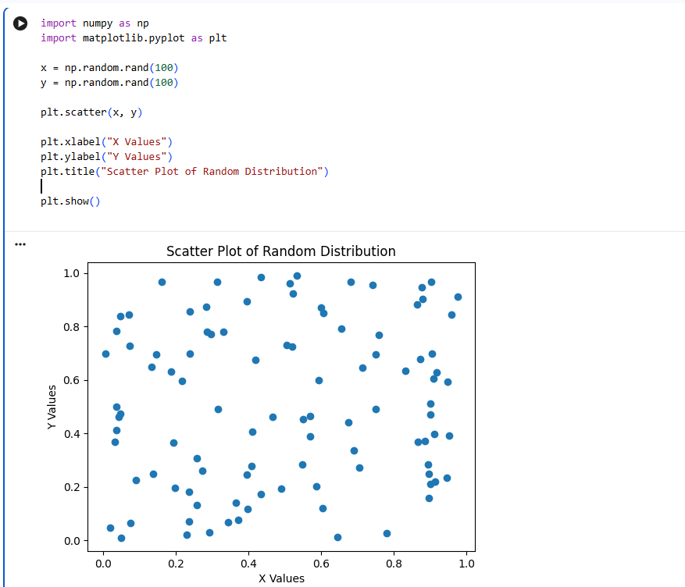
Result
A scatter graph containing 100 randomly distributed X and Y points was successfully displayed
33. Scatter Plot with Empty Circles
Aim
To write a Python program to draw a scatter plot using random X and Y distributions with empty circles.
Algorithm
- Import NumPy and Matplotlib.
- Generate random X and Y values.
- Use the scatter() function with an empty face color.
- Set the marker as a circle.
- Add suitable labels and title.
- Display the graph.

Google Colab Code
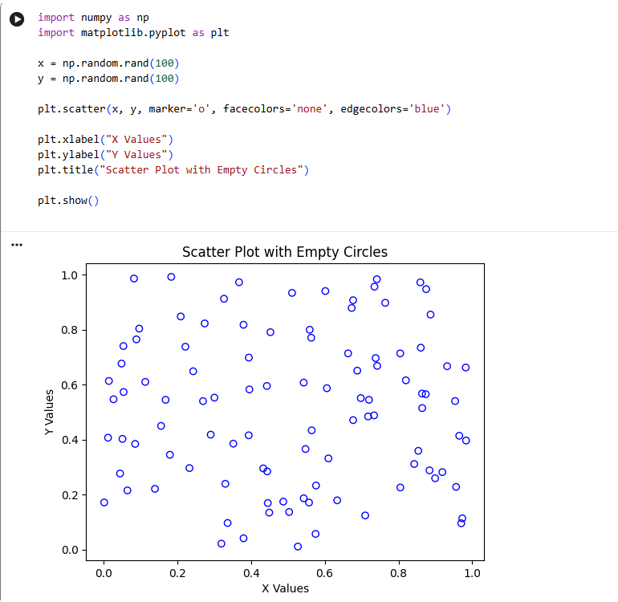
Result
A scatter plot with randomly distributed points represented by empty circles was successfully displayed.
34. Scatter Plot with Balls of Different Sizes
Aim
To write a Python program to draw a scatter plot using random distributions and generate balls of different sizes.
Algorithm
- Import NumPy and Matplotlib.
- Generate random X and Y values.
- Generate random sizes for the scatter points.
- Pass the sizes to the s parameter of scatter().
- Add suitable labels and title.
- Display the graph.

Google Colab Code
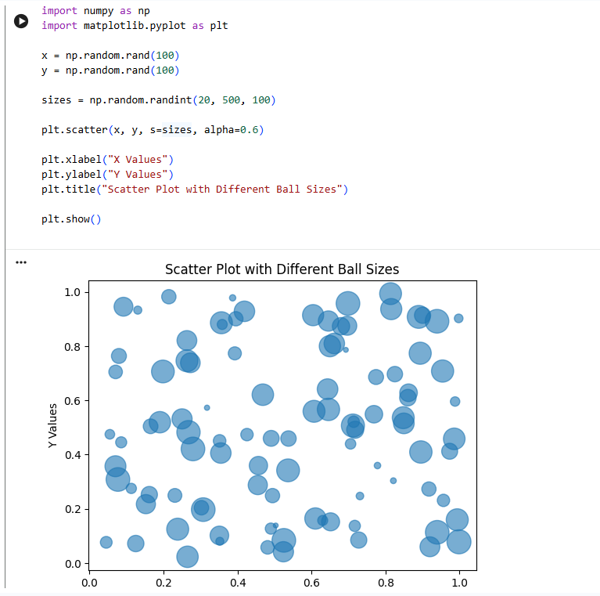
Result
A scatter plot was successfully created with randomly distributed balls of different sizes.
35. Scatter Plot Comparing Two Subject Marks
Aim
To write a Python program to draw a scatter plot comparing the marks obtained by students in two different subjects.
Algorithm
- Import Matplotlib.
- Define the marks of students in two subjects.
- Plot the marks using the scatter() function.
- Label the X-axis and Y-axis.
- Add a suitable title.
- Display the scatter plot.

Google Colab Code
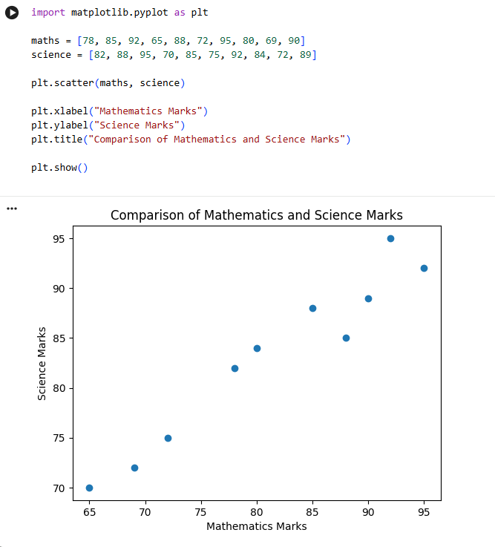
Result
A scatter plot was successfully created to compare students' Mathematics and Science marks.
36. Scatter Plot for Three Groups Comparing Weight and Height
Aim
To write a Python program to draw a scatter plot for three different groups comparing their weights and heights.
Algorithm
- Import Matplotlib.
- Define height and weight values for three groups.
- Plot the three groups using the scatter() function.
- Use different colors and markers for each group.
- Add X-axis and Y-axis labels.
- Add title and legend.
- Display the scatter plot.
Google Colab Code
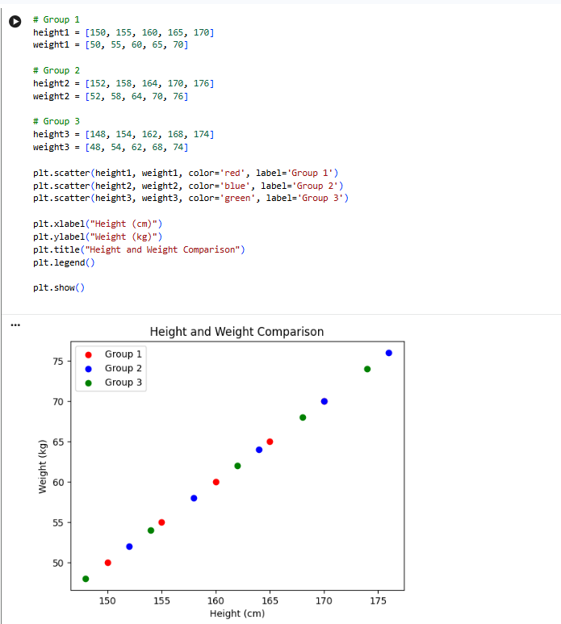
Result
A scatter plot was successfully created to compare height and weight for three different groups.
37. Create a DataFrame from a Dictionary
Aim
To write a Pandas program to create a DataFrame from a dictionary and display it.
Algorithm
- Import the Pandas library.
- Create a dictionary containing student information.
- Convert the dictionary into a DataFrame using pd.DataFrame().
- Display the DataFrame.
Google Colab Code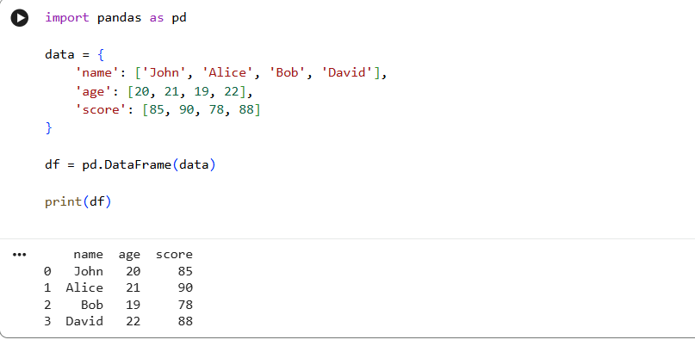

Result
Thus, a DataFrame was successfully created from the given dictionary and displayed.
38. Create DataFrame from Dictionary with Index Labels
Aim
To write a Pandas program to create and display a DataFrame from a specified dictionary with index labels.
Algorithm
- Import Pandas.
- Create a dictionary containing the required data.
- Define the index labels.
- Create the DataFrame using pd.DataFrame().
- Display the DataFrame.
Google Colab Code
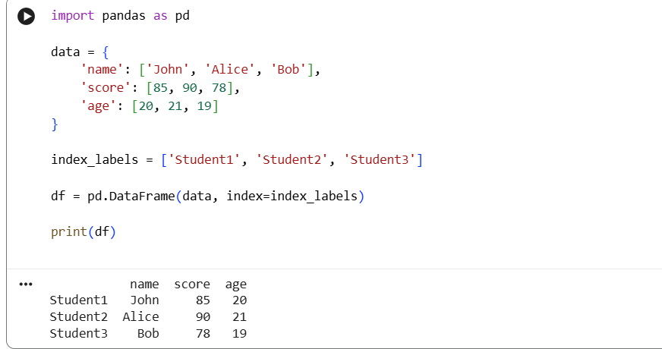
Result
Thus, the DataFrame was successfully created and displayed with the specified index labels.
39. Get the First 3 Rows of a DataFrame
Aim
To write a Pandas program to retrieve and display the first three rows of a given DataFrame.
Algorithm
- Import Pandas.
- Create the DataFrame.
- Use the head(3) function to select the first three rows.
- Display the selected rows.
Google Colab Code
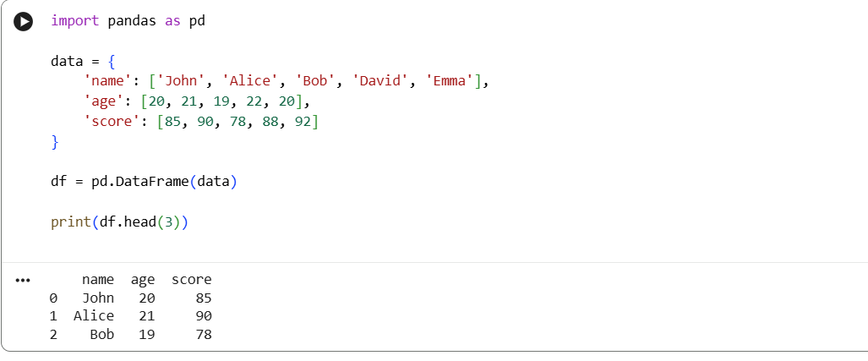
Result
Thus, the first three rows of the DataFrame were successfully displayed.
40. Select the Name and Score Columns
Aim
To write a Pandas program to select the name and score columns from a given DataFrame.
Algorithm
- Import Pandas.
- Create the DataFrame.
- Select the name and score columns using column indexing.
- Display the selected columns.
Google Colab Code
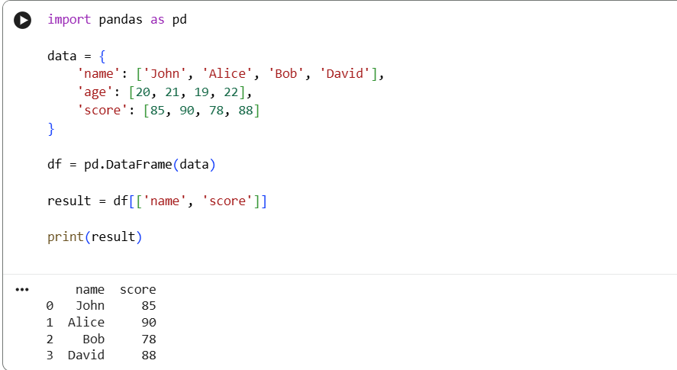
Result
Thus, the name and score columns were successfully selected and displayed.

